**D365 AP Automation Analysis**

Initial page can`t be access due to permissions constraint, so they ask us to test on other similar page instead.

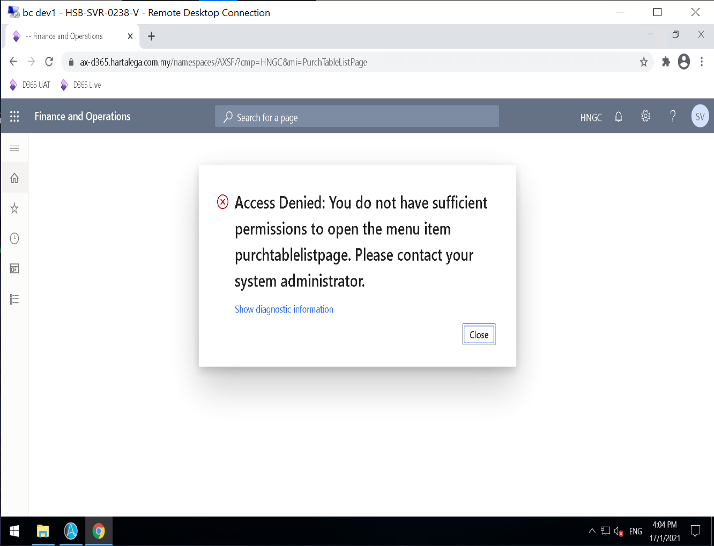

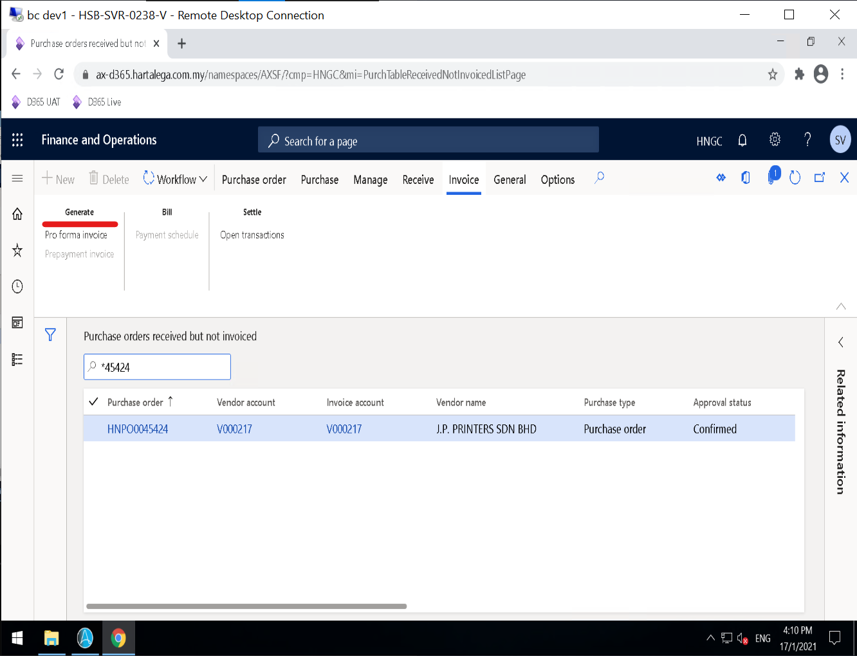

From the high-level look, the fields are match. Next they will navigate to Generate > Invoice but on provided page there was no “Invoice”. I believed the “Pro-forma Invoice” was the same things, even some button`s not there, and this should suffice for our cases. So we will proceed with the provided page.

**Entry-point**

|  |  |
| --- | --- |
| Navigation | Enter D365 |
| Navigate to **All** **purchase orders** |

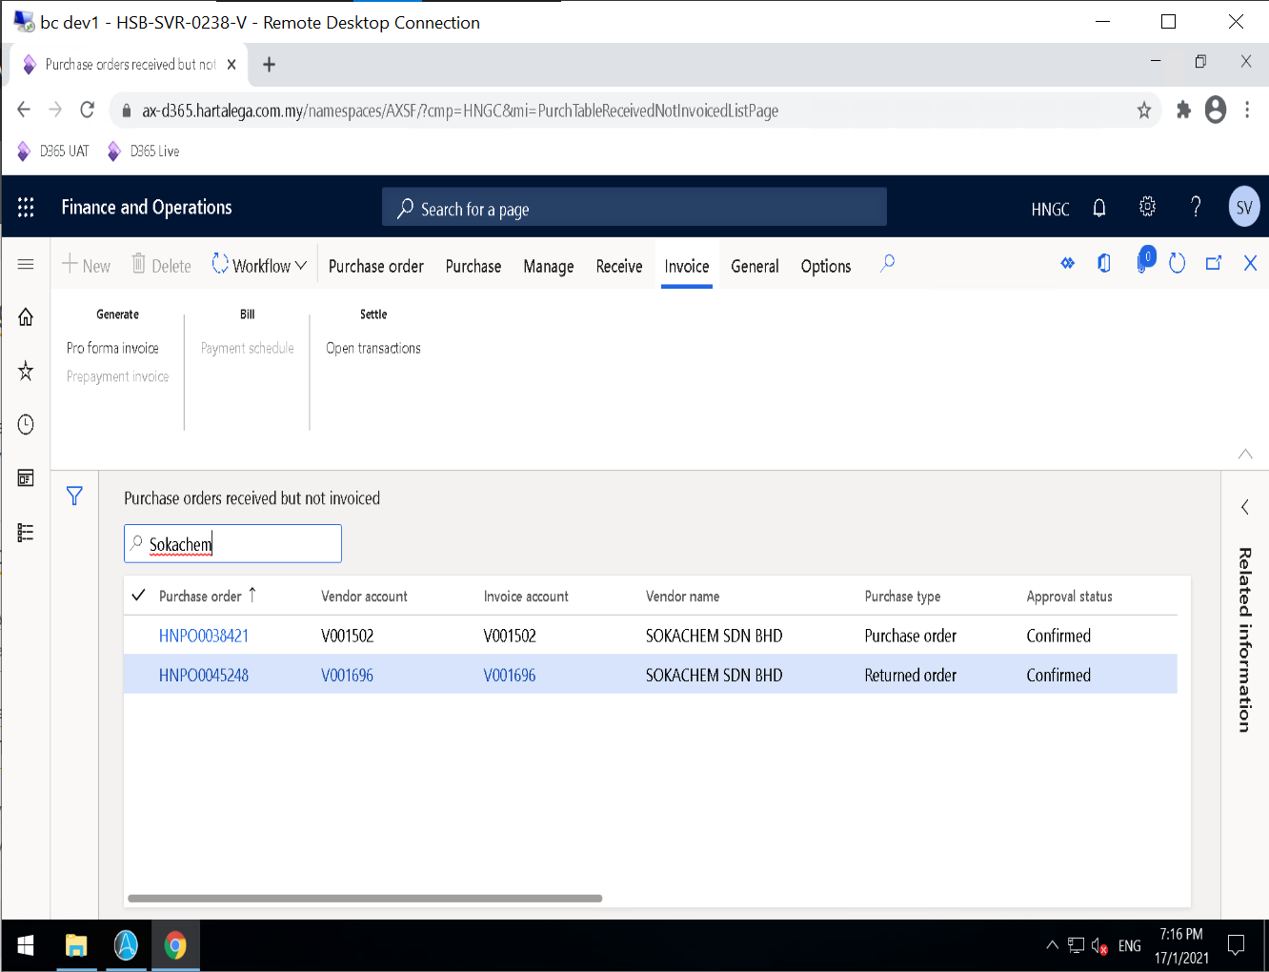

|  |  |
| --- | --- |
| Navigation | Select **Purchase Oder** |
| Select **Generate – Pro forma invoice** |

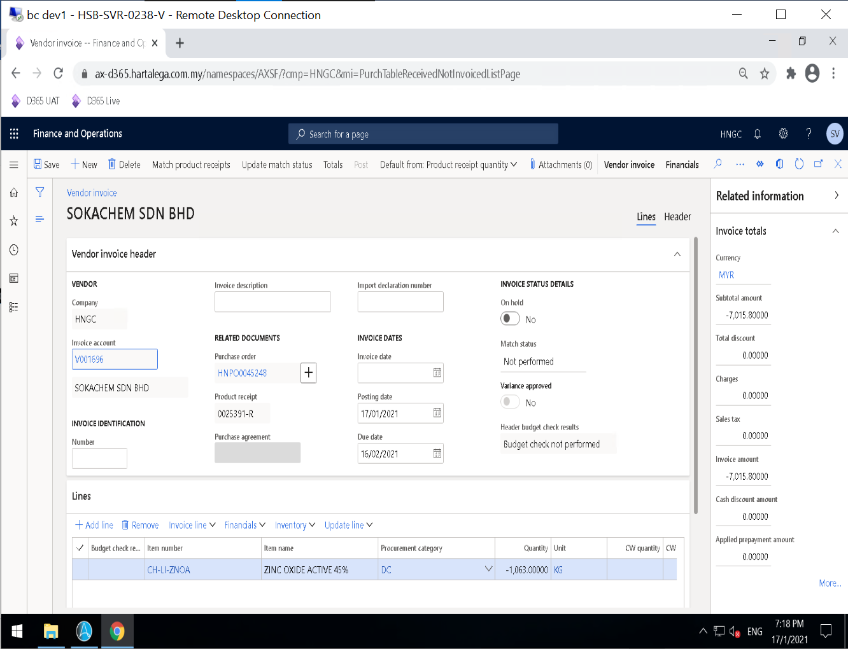

**High-Level Process Flow**

Structured flowchart: Page 1

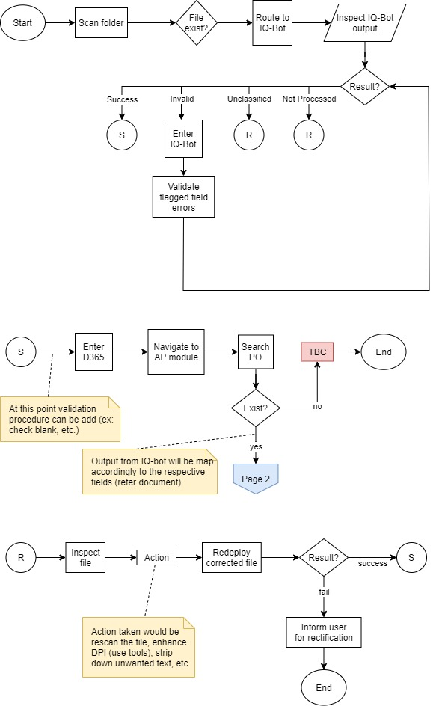

Structured flowchart: Page 2

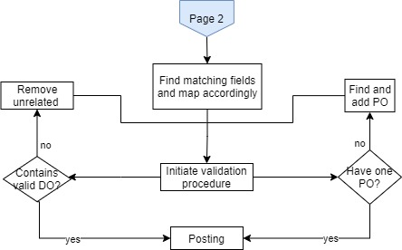

**Fields**

|  |  |  |  |
| --- | --- | --- | --- |
| Name | Type | Invoice Fields | D365 Fields |
| Invoice No | Numeric | INVOICE NUMBER | Number |
| Invoice Date | Date | INVOICE DATE | Invoice date |
| PO No | Alphanumeric | PO NO | Purchase order |
| DO No | Alphanumeric | DELIVERY ORDER NO | Product receipt |
| RETD | Date | REQUEST DATE | N/A |
| Item No | Numeric | ITEM NO | Item number |
| Description | Text | DESCRIPTION OF ITEM AND PACK | Item name |
| Quantity | Numeric | NO OF PACKS | Quantity |
| Total Amount | Numeric | TOTAL AMOUNT | Subtotal amount |

|  |  |
| --- | --- |
|  | Data mapping members |
|  | Validation point |

**Invoice Field Mapping**

Open this pdf document ([Invoice - CCM Chemicals.pdf](sample%20of%20invoice/Invoice%20with%20PO/CCM%20Chemicals.pdf)) for the details on sample mapping.